**NITTE MEENAKSHI INSTITUTE OF TECHNOLOGY**

**(An autonomous institution with A Grade by NAAC /UGC, Affiliated to Visvesvaraya Technological University,**

**Belgaum, Approved by UGC/AICTE/Govt. of Karnataka)**  **Yelahanka, Bengaluru-560064**

**ACADEMIC YEAR 2020-2021**



**SUBJECT: HYBRID APP DEVELOPMENT**

**LA-2 REPORT**

**Submitted to:**

# Prof.Prashanth B.S

**Submitted by:**

**Deshmukh Pankaj(1NT17IS0047)**

**Deepak Kumar(1NT17IS045)**

# Stopwatch APP

The stopwatch is basically a timepiece that is designed particularly to measure the time elapsed between the activation and deactivation of the stopwatch. The users can start the Stopwatch and stop it anytime. It was originally invented by Samuel Watson. There is also a button to restart the stopwatch that will set the stopwatch to starting. So our task is to make an application for Stopwatch which can be used whenever required

**GitHub link:**

**Code:**

**1.** **activity_main.xml** :

<?xml version="1.0" encoding="utf-8"?>  
<LinearLayout  
 xmlns:android="http://schemas.android.com/apk/res/android"  
 xmlns:tools="http://schemas.android.com/tools"  
 android:layout_width="match_parent"  
 android:layout_height="match_parent"  
 android:orientation="vertical"  
 android:background="#C0E7EC"  
 android:padding="16dp"  
 tools:context="com.ProjectGurukul.stopwatch.MainActivity">  
  
 <TextView  
 android:id="@+id/time_view"  
 android:layout_width="wrap_content"  
 android:layout_height="wrap_content"  
 android:layout_gravity="center_horizontal"  
 android:layout_marginTop="100dp"  
 android:background="@drawable/border"  
 android:textAppearance="@android:style/TextAppearance.Large"  
 android:textSize="50dp" />  
  
 <Button  
 android:id="@+id/start_button"  
 android:layout_width="wrap_content"  
 android:layout_height="wrap_content"  
 android:layout_gravity="center_horizontal"  
 android:layout_marginTop="50dp"  
 android:onClick="onClickStart"  
 android:text="@string/start" />  
  
 <Button  
 android:id="@+id/stop_button"  
 android:layout_width="wrap_content"  
 android:layout_height="wrap_content"  
 android:layout_gravity="center_horizontal"  
 android:layout_marginTop="50dp"  
 android:onClick="onClickStop"  
 android:text="@string/stop" />  
  
 <Button  
 android:id="@+id/reset_button"  
 android:layout_width="wrap_content"  
 android:layout_height="wrap_content"  
 android:layout_marginTop="50dp"  
 android:layout_gravity="center_horizontal"  
 android:onClick="onClickReset"  
 android:text="@string/reset" />  
</LinearLayout>

**2.** **MainActivity.java** **file** :

package com.example.projectgurukulstopwatch;  
  
import android.os.Bundle;  
import android.app.Activity;  
import android.os.Handler;  
import android.view.View;  
import java.util.Locale;  
import android.widget.TextView;  
public class MainActivity extends Activity {  
 private int sec = 0;  
 private boolean is_running;  
 private boolean was_running;  
 @Override  
 protected void onCreate(Bundle savedInstanceState)  
 {  
 super.onCreate(savedInstanceState);  
 setContentView(R.layout.*activity_main*);  
 if (savedInstanceState != null) {  
 sec = savedInstanceState.getInt("seconds");  
 is_running = savedInstanceState.getBoolean("running");  
 was_running = savedInstanceState .getBoolean("wasRunning");  
 }  
 running_Timer();  
 }  
 @Override  
 public void onSaveInstanceState(  
 Bundle savedInstanceState)  
 {  
 savedInstanceState.putInt("seconds", sec);  
 savedInstanceState.putBoolean("running", is_running);  
 savedInstanceState.putBoolean("wasRunning", was_running);  
 }  
 @Override  
 protected void onPause()  
 {  
 super.onPause();  
 was_running = is_running;  
 is_running = false;  
 }  
 @Override  
 protected void onResume()  
 {  
 super.onResume();  
 if (was_running) {  
 is_running = true;  
 }  
 }  
 public void onClickStart(View view)  
 {  
 is_running = true;  
 }  
 public void onClickStop(View view)  
 {  
 is_running = false;  
 }  
 public void onClickReset(View view)  
 {  
 is_running = false;  
 sec = 0;  
 }  
 private void running_Timer()  
 {  
 final TextView t_View = (TextView)findViewById(R.id.*time_view*);  
 final Handler handle = new Handler();  
 handle.post(new Runnable() {  
 @Override  
 public void run()  
 {  
 int hrs = sec / 3600;  
 int mins = (sec % 3600) / 60;  
 int secs = sec % 60;  
 String time_t = String .*format*(Locale.*getDefault*(), " %d:%02d:%02d ", hrs,mins, secs);  
 t_View.setText(time_t);  
 if (is_running) {  
 sec++;  
 }  
 handle.postDelayed(this, 1000);  
 }  
 });  
 }  
}

3. **string.xml :**

<resources>  
 <string name="app_name">ProjectGurukul Stopwatch</string>  
 <string name="start"> Start </string>  
 <string name="reset"> Reset </string>  
 <string name="stop"> Stop </string>  
</resources>

1. **Border.xml** :

<?xml version="1.0" encoding="utf-8"?>  
<shape xmlns:android="http://schemas.android.com/apk/res/android"  
 android:layout_width="match_parent"  
 android:layout_height="match_parent"  
 android:shape="rectangle">  
 <stroke  
 android:width="2dp"  
 android:color="#932424" />  
</shape>

**SCREENSHOTS:-**

**1)home page:-**

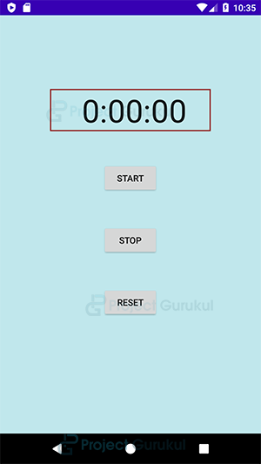

**2)START:-**

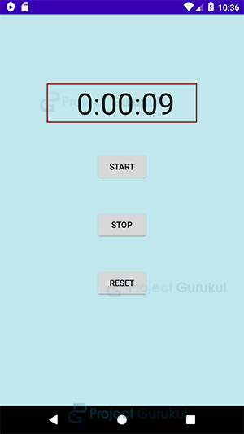

**3)STOP:-**

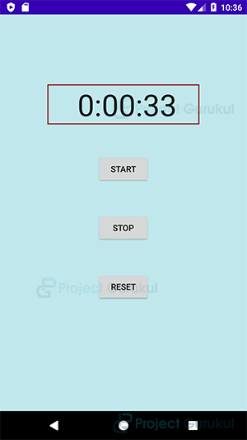

**4)Restat:-**

